Course Title: Social Immersive Learning
Course Code: 24UC0021
Name: L.Ishitha
Roll No: 2420030041
Section: 10

Title of the Event:
ACM Mahotsav

Organized by:
Association for Computing Machinery (ACM) Student Chapter, KLH University – Bachupally Campus

Dates:
August 29–08, 2025 | 9:30 AM – 4:30 PM

Event Summary:
ACM Mahotsav is a prestigious annual technical festival organized by the ACM Student Chapter at KLH University. The event celebrates innovation, technology, and problem-solving by bringing together students, developers, and industry professionals. It features a wide range of activities, including hackathons, coding contests, workshops, tech talks, and exhibitions focused on the latest advancements in computing. The main objective of the event is to foster a spirit of collaboration and innovation while providing a platform for students to enhance their technical skills and creativity. Participants had the opportunity to interact with mentors, share ideas, and gain exposure to emerging technologies shaping the future of the IT industry.

Key Highlights:
- Coding competitions, hackathons, and innovation challenges.
- Expert sessions and technical talks by industry professionals.
- Workshops on Artificial Intelligence, Machine Learning, and Cloud Computing.
- Opportunities for students to network and collaborate with peers and mentors.
- Recognition and awards for outstanding projects and innovative solutions.

My Participation:
I actively participated in the ACM Mahotsav and attended several technical workshops and interactive sessions. The event helped me gain practical insights into coding techniques, AI trends, and real-world software development practices. I also interacted with participants from different branches, which enhanced my teamwork and problem-solving abilities. The sessions inspired me to explore new areas of technology and motivated me to continue improving my programming and analytical skills.

Event Photographs:
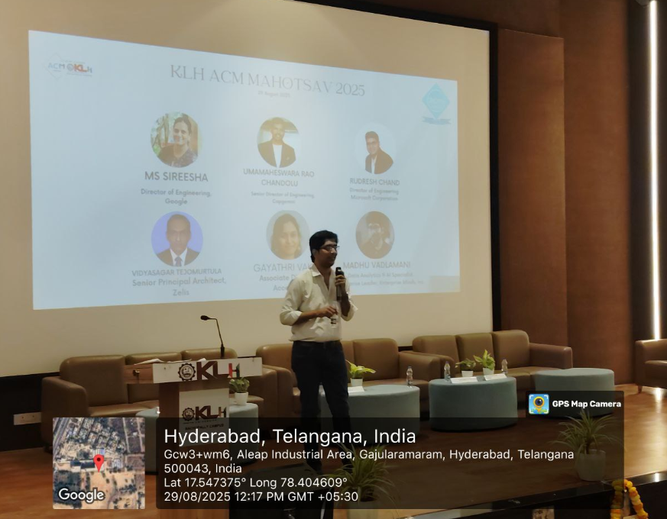

Conclusion:
ACM Mahotsav was a highly enriching and inspiring experience that strengthened my understanding of modern computing technologies. It provided a valuable platform to learn, collaborate, and innovate alongside passionate individuals. The event enhanced my confidence, technical knowledge, and enthusiasm for pursuing excellence in the field of computer science.

Acknowledgment:
Special thanks to KLH University and the ACM Student Chapter for organizing the ACM Mahotsav and for providing an excellent opportunity to engage with technology, creativity, and in

